 | C R RAO Advanced Institute of Mathematics, Statistics and Computer Science (AIMSCS) in Collaboration with Jawaharlal Nehru Technological University Hyderabad | 

Analysis of Diabetes using ML through R and Python

A dissertation submitted to the CRRAO AIMSCS in partial fulfillment of the requirements for the Completion of the Course

Real Time Projects/Societal Needed Projects
by

AZHAR-22XV1M6706

HARSHIT-22XV1M6709

HARDHIK-22XV1M6717

P.VAISHNAVI-22XV1M6723

YASHASWINI-22XV1M6726

# Projects outside CRRAO
Supervisor: Dr.G.padmavathi
Mentor: for internship mentor name
# Projects with in CRRAO

Date of Submission: 19th July 2024

CERTIFICATE
This is to certify that the dissertation entitled ----------------------submitted by Team, bearing Roll nos , in partial fulfillment of the requirements for the award of Master of Technology in Information Security, is a bonafide work carried out by him under my supervision and guidance.

The dissertation has not been submitted previously in part or in full to this or any other University or Institution for the award of any degree or diploma.

Dr.G. Padmavathi
B.Tech Coordinator
CRRAO,AIMSCS

Declaration
I,__________________________________here by declare that this dissertation entitled ___________________________________ submitted by me under the supervision of Dr.G.Padmavathi and Mentored by __________________. I also declare that it has not been submitted previously in part or in full to this University or any other University or Institution for the award of any degree or diploma or Projects

A report of plagiarism statistics from the college is enclosed.

Date:19/07/2024
Place:

AZHAR-22XV1M6706

HARSHIT-22XV1M6709

HARDHIK-22XV1M6717

P.VAISHNAVI-22XV1M6723

YASHASWINI-22XV1M6726

(Dr.G.Padmavathi)
Supervisor& HOD

Acknowledgement
It gives me utmost pleasure to express my profound sense of gratitude and sincere thanks to Dr.G. Padmavathi and Mentor name___________ for her continuous guidance, support, and encouragement in carrying out this work.

I would like to express my sincere regards to my family and friends for their continuous support.

With Sincere Regards, Team Members:
AZHAR
HARSHIT
HARDHIK
P.VAISHNAVI
YASHASWINI

Table of Contents

CHAPTER-1 : INTRODUCTION

CHAPTER-1.1 : MOTIVATION

CHAPTER-2 : LITERATURE SURVEY

CHAPTER-2.1 : INTRODUCTION TO DATASETS

CHAPTER-3 : GOAL AND OBJECTIVES
CHAPTER-3.1 : OBJECTIVE-1
CHAPTER-4 : ALGORITHMS
CHAPTER-4.1 : OBJECTIVE-2

CHAPTER-5 : CONCLUSION AND FUTURE WORK

REFERENCE & LINKS

List of Figures

Figure 1 : Analysis types on a dataset
Figure 2 : Aspects of Covid-19 dataset
Figure 3 : Aspects of the ADNI dataset
Figure 4 : Various aspects of The Cardiovascular Diseases dataset

Figure 5 : Pictorial overview of a melanoma dataset
Figure 6 : Overview of Nationwide Inpatient Sample dataset

Figure 7 : Insights on choosing to analyze the 10 Years Diabetes Dataset over other datasets
Figure 8 : Data Preprocessing

Figure 9 : Key concepts of Random Forest Algorithm

Figure 10 : Key concepts of SVM Algorithm

Figure 11: Key concepts of Logistic Regression Algorithm

Figure 12: Table for accuracy Values of Different Datasets

Chapter-1.1

INTRODUCTION:

It has huge series data of patient demographics, clinical observations, diagnostic tests, treatment plans, and outcomes, among many others. Such indispensable resources make studying trends, patterns, and insights for the improvement of patient care, advancement of medical research, and healthcare systems optimization easier to achieve for researchers, data scientists, and healthcare practitioners.

Figure 1: Analysis types on a dataset
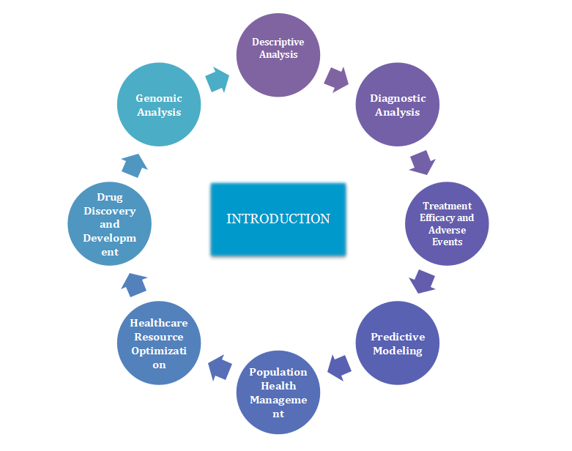

❖Analysing Traits Descriptively: This basic research describes to identifiable features within a patient group that have to be known to understand healthcare needs and create actions. For example, geospatial data might give out the variation of geography-based access to health facilities; at the same time, demographic features like age distribution may help in recognizing health problems unique to a particular age group.
- ﻿Diagnostic exams: Using diagnostic information, researchers can develop algorithms designed to facilitate analysis and type. One instance is while system getting to know fashions trained with scientific photo statistics assist radiologists identify anomalies indicative of cancer or neurological sickness In the same vein, early detection and threat evaluation may be improved through diagnostic biomarkers because of lab take a look at results.
- Effectiveness of Treatment: One can consider treatment outcomes along with adverse events if one is a fitness care provider interested in assessing the effectiveness and safety of treatment strategies. Comparative-effectiveness research includes the evaluation of the results of opportunity treatments as a way to guide proof-based totally remedy alternatives. Additionally, postmarket drug protection is controlled through drug monitoring efforts that use actual-global data to discover and examine drug abuse

- Predictive Modeling: It makes use of historical data in predicting future events or results. Such insights are very helpful in terms of proactive intervention and chance management. One example of predictive analytics could be the identification of sufferers at high danger of hospital readmission or complication, thus allowing healthcare suppliers to take preventive measures or alter remedy plans. Furthermore, predictive methods can help personalized medicine initiatives by personalizing remedy methods to a particular person traits and threat profiles.

- Population Health Management: Cluster of population-level analyses provides a microscopic view of health trends and diversity within a network or population institution. Epidemiological researches make use of the medical data sets in order to track disease incidence, detect risk factors, and monitor the relative impact of public health interventions. This information is used by population health management strategies in the design of focused interventions aimed at improving health.

- Optimization of Healthcare Resources: Information from the investigation of styles in healthcare use will help organizations draw out inefficiencies and cleanse workflows to optimize aid allocation. Using data-driven insights that permit strategic allocation of assets in a way that meets affected person wishes, health systems may be capable of assignment demand for healthcare services and optimize staffing degrees.Beyond that, the analytics in healthcare discover opportunities to comprise value and decrease waste to make sure standard efficiency and sustainability in healthcare shipping.
- Drug Discovery and Development: Medical datasets come in handy in accelerating drug discovery and development by performing target identification, compound screening, and clinical trial designs. Bioinformatics analyses bring together genomic, proteomic, and metabolomic data to understand the mechanism of the disease, identify probable targets that the drug can act on, and prioritize some candidate compounds for further investigation. The analysis of clinical trial data assures the safety and efficacy of investigative drugs and thus helps in decision-making at each step of drug development.

- Genomic Analysis: Genomic data analysis has huge potential for personalized medicine, in which it can help treatment decisions based on the genetic profile of the patient. Genomic data can be integrated into clinical information about a patient for the detection of genetic variation, predisposition to diseases, response to treatment, and metabolism of drugs. Pharmacogenomic analysis drives medication selection and dosing in the light of patient genotype to maximize therapeutic efficacy while avoiding adverse drug reactions.
Such diverse analyses improve, in an aggregate way, medical knowledge, patient outcomes, and healthcare delivery across the continuum of care. Stakeholders can activate the potential of medical data to extract actionable insights that help address pressing healthcare challenges and drive innovation in clinical practice and research.There are many Healthcare datasets available for analysis , some are:

Here are some disease-specific datasets:
- ﻿COVID-19 datasets:
Stacks of datasets immediately and not directly connected to the COVID-19 pandemic, like case counts, vaccination prices, and genomic sequences, are to be had through sources just like the WHO, CDC, and Johns Hopkins University.Johns Hopkins COVID-19 Data Repository: [Github Repository link] .This dataset includes a big extent of information on the pandemic, especially on day by day cases, deaths, recovered instances, and vaccination costs from all over the international. Data is organized at a country level and from time to time at a local level within countries. It has had huge usage amongst researchers, decision-makers, and the general public in tracking the development of the pandemic.

Figure 2 : Aspects of Covid-19 dataset

1.Case Counts: This dataset contains daily case counts of confirmed cases, death, and recovery cases of COVID-19. On the whole, these case counts are normally reported at the country or regional level and are aggregated from many sources, including official health departments, hospitals, and research institutions.
﻿2. Vaccination rates: It also presents info on vaccination costs in phrases of the range of administered doses, completely vaccinated people, and the share proportion of the population this is vaccinated towards COVID-19. This statistics will significantly assist in tracing how vaccination campaigns are going for walks and reviewing their effect on the spread of this virus.
3. Geographic Coverage: The dataset has data for countries and regions from all parts of the world. This gives a worldwide dimension to the pandemic. In that way, one would look into trends and responses across different countries and regions.

4. Time Series Data: Probably one of the most interesting features of this dataset is that the data reported is time series in nature, with some extended time instances being accounted for on a daily basis. This will enable trend analysis over time and the identification of peaks, troughs, and seasonal patterns in case counts and vaccination rates.

5. Data Quality and Sources: This dataset assures that a very high level of requirement regarding the quality of the statistics to be delivered accurately and fresh, within the proposed counts. It identifies sources that shall be used, such as WHO—World Health Organization, countrywide fitness departments, and other credible sources.
6. Data Format: The dataset is generally to be had in a based format, such as a CSV file, with every row representing a particular date and region (e.G., country or region) and columns representing distinct metrics (e.G., confirmed cases, deaths, vaccinations).

7. Data Visualization: This dataset will very often be used to construct visualizations—including, but not limited to, line graphs, bar charts, maps, and so forth—to understand the spread of the virus and the effect of vaccination campaigns, among other trends that emerge.
8. Data Analysis: This dataset enables a number of varying analyses, such as epidemiological modeling, trend analysis, and forecasting, all of which help inform broader public health policies and certain other interventions put in place to control the virus.

9. Global Collaboration: The dataset becomes part of the global effort to trace and act on COVID-19. Much of the time, that helps with other datasets and research efforts to provide an overall understanding of the impact of the pandemic.
The COVID-19 dataset serves as a very valuable tool for researchers, policy decision-makers, and the general public in the tracing of progress in the pandemic, comprehension of its impact, and informing effective responses to mitigate its spread.

2. ADNI[Alzheimer's Disease Neuroimaging Initiative]:
A dataset about Alzheimer's disease, including neuroimaging data, genetic data, and other features such as cognitive assessments.
ADNI: This Alzheimer's Disease Neuroimaging Initiative dataset is a long-term, multi-modal database with deep coverage of subjects having AD and related neurodegenerative diseases. It is a multicenter project involving academic research centers, pharmaceutical companies, and government agencies in an effort to expedite the discovery of biomarkers for the early identification and monitoring of AD progression. The ADNI database houses all sorts of data modalities: neuroimaging, genetic information, clinical assessments, data on cognitive functions, and, last but not least, biospecimens—a rich resource for those studying different aspects of the pathophysiology, diagnosis, and treatment of AD.
ADNI
Here's a detailed exploration of each aspect of the ADNI dataset:

Figure 3 : Aspects of the ADNI dataset

Neuroimaging information: ADNI has magnetic resonance imaging, magnetic resonance imaging, and positron emission tomography imaging available for AD patients, those with mild cognitive impairment, and healthy controls. Functional magnetic resonance imaging demonstrates the benefits of cognitive-behavioral approaches that provide insight into changes in neural networks underlying cognitive decline. Positron emission tomography imaging with
radiotracers targeting amyloid-β and tau protein aggregates in vivo detects AD symptoms and is useful in diagnosing and monitoring disease progression. Positron emission tomography imaging and radiotracers targeting amyloid-β and tau protein aggregates allow in vivo detection of AD markers and is useful in diagnosing and monitoring disease progression.
2. Genetic information: Genetic information is available for each subject; Data collected included genotyping and whole genome sequencing. ADNI is studying DNA risk factors such as apolipoprotein E genotype and other GWAS genetic variants that influence AD ​​susceptibility, pathogenesis, and recently treatment response using clinical trials. As a result, most of the genes in the AD risk loci catalog were identified using a genome-wide association of
genes, which were then aggregated into multiple genetic risk scores to determine an individual’s risk of developing AD or another type of dementia.
3. Clinical Assessment: ADNI includes a battery of clinical tests and neuropsychological assessments administered to members on a regular basis. Assessments include measures of cognition, memory, executive function, language skills, and activities of daily living. Common cognitive assessment tools, such as the Mini-Mental State Examination and the Alzheimer's Disease Assessment Scale - Cognitive Subscale, allow for assessment of changes in overall cognitive performance over
years and measurement of disease severity. It also includes demographic information, medical outcomes, and medication use from participant clinical and medical history questionnaires.
4. Cognitive function: Detailed information is available on participants’ cognitive function assessed by various psychological tests and medical reports in ADNI. Longitudinal assessment of cognitive decline in domains commonly affected by AD. Summary of multitask scores on standardized cognitive tests that measure general cognitive function and are useful measures in clinical trials to investigate possible AD.
5. Biospecimens: ADNI collects blood, CSF, and other biological samples from tissues to be used for biomarker testing. This will be a molecular marker for AD pathology, together with the level of amyloid beta and tau protein in CSF and blood-based blood, which are mainly indicative of neuroinflammation, synaptic dysfunction and neuronal damage. The biomarker profiles obtained from this analysis of biosamples will contribute to early disease detection, diagnosis of various diseases and monitoring of treatment outcomes in clinical trials for AD treatment.
6. Long-term follow-up: This is one of the strongest points of ADNI: the design allows for continuous follow-up of subjects over many years. In this context, longitudinal data will be collected to capture changes in disease progression, cognitive decline and biomarker profiles over time, allowing the natural history of AD to be elucidated and predictors of disease progression to be identified. Longitudinal analysis in ADNI
defines the course of cognitive decline, identifies biomarkers of disease progression, and assesses the importance of interventions to slow or halt AD progression.
Datasets such as ADNI are therefore invaluable for a variety of studies on AD and neurogenerative diseases in general. They will improve the understanding of disease mechanisms and the development of new diagnostic tools and therapeutic targets. Integrating neuroimaging, genetic, clinical, cognitive, and biomarker data through ADNI to advance collaborative research aimed at accelerating the development of effective AD treatments and improving patient outcomes.
3. Heart disease screening:
Cardiovascular disease datasets are crucial to understanding and addressing public health issues such as cardiovascular disease, which remains the leading cause of death worldwide.
[https://github.nl.com/caravanuden/root]
Cardiovascular Dataset: This is a free dataset shared on Kaggle that contains 70,000 records, of which 34,979 show patients with heart disease and 35,021 do not. It has eleven built-in competencies in demography, testing, and social work, each with four variables, except for social writing, which has three positive variables.
The dimensions variously describe the subsequent in precise:

Figure 4 : Various aspects of The Cardiovascular Diseases dataset.
1. Demographic Information: Information about the people that make up your statistics set, as an instance, age, sex, ethnicity/race. Demographic statistics is useful to understand trends and hazard elements for precise populations.
﻿2. Clinical Measurements: Some of the essential clinical measurements have to do with key health metrics, blood stress, levels of cholesterol, and blood glucose tiers which move further to determine body mass index. These metrics offer insights into cardiovascular risk elements and sickness improvement.
﻿3. Medical History: It includes facts about the affected person's past cardiovascular occasions, associated ailments—which include high blood pressure and diabetes—and present day medicines. It publications evaluation of the recognition and dreams of the character for treatment.
4. Diagnostic Tests and Procedures: This accommodates the results from diagnostic tests and strategies, consisting of electrocardiograms, echocardiography, and cardiac catheterization, and it assists in arriving at the diagnoses of the cardiovascular conditions and estimating their severity.
5. Outcomes and Follow-up: Outcomes data include incidence of cardiovascular events—e.g., myocardial infarction or strokes—and mortality rates, and longitudinal data for following up on changes over time. The results of some interventions or treatments need to be known due to the evaluation effectiveness.
6. Lifestyle Factors: Dietary habits, alcohol intake, and stressful life are significant contributory factors to cardiovascular health related to lifestyle factors. Monitoring these factors allows for the identification of modifiable risk factors and formulates appropriate preventive strategies.
7. Genetic and biomarker data: Genetic alterations and biomarkers provide information about genetic factors and biochemical processes associated with heart disease. Genetic and biomarkers can be combined to improve risk factors and develop more personalized treatments.
Some of these are numerical attributes; some are categorical, coded, and some are binary. The course is balanced, but there are more female patients than male patients. Furthermore, fixed-valued factors are almost always distributed, and highly valued categories are shown to be 'normal' as opposed to 'high' levels of disease-causing factors.
4. The Cancer Genome Atlas (TCGA): This is a large dataset of genomic and clinical data on many types of cancer. Concisely, multi-dimensional genomic data in the TCGA dataset consists of DNA sequencing, gene expression profiling, DNA copy number variations, and epigenetic modifications across many types of cancers.
TCGA: The cancer genome atlas
The Cancer Genome Atlas Program. NCI

Figure 5 : Pictorial overview of a melanoma dataset
﻿Thus,that is a precise of statistics contained in the melanoma dataset:
1) Information of sufferers:
•Demographic information: statistics approximately age, sex, ethnicity, or every other characteristic of relevance.
• Family History: Details of family history of cancer or various skin cancers;
• Risk Factors: Information should be shared about risk factors, including sun exposure, a history of severe sunburns, tanning beds, presence of atypical moles.
2) Clinical Information
• Tumour Characteristics: Melanoma tumor characteristics : anatomic site of melanoma, size, thickness in millimeter, Breslow thickness, and ulceration status
• Tumor Stage: Melanoma staging AJCC staging system.
• Histopathological Features: Information on histological subtypes of melanoma and other histopathological features observed in biopsy specimens.
• Presence of Metastasis: Information on whether or not melanoma has invaded regional lymph nodes or other distant organs.
3) Diagnostic Procedures:
• Biopsy Results: Findings from skin biopsy procedures that were done to confirm the diagnosis of melanoma and characterize it.
﻿Imaging studies: Results of ultrasound, MRI, CT, or PET experiment imaging to investigate the amount of disorder and metastases.
4) Treatment:
• Surgical Procedures: Information on cancer surgery, including extended extension, lymph node dissection, and sentinel lymph node biopsy.
• Adjuvant therapy: Information on chemotherapy, immunotherapy, targeted therapy, or radiation therapy after surgery.Systemic Therapy: Treatment given in the setting of metastatic melanoma, involving systemic therapies like immunotherapy or targeted therapy, including inhibitors of the checkpoints and BRAF.
5) Treatment Response:
• Treatment Response: Whether or not patients showed regression, stabilization, or progression to the different treatments administered.
• Adverse Events: The adverse events during the treatment process that the patients have gone through.
6) Variables
• Overall survival: time from diagnosis or start of treatment to death from any cause.
• Progression-free survival: time from diagnosis or start of treatment to first signs of disease recurrence or death.
• Review: data on recurrence of previously treated cancer.This furnished dataset might be beneficial for a big range of packages, including medical research, growing fashions of affected person final results predictions, determining prognostic elements, measuring the effectiveness of remedies, and accomplishing higher medical control strategies in patients affected by cancer.
5. Nationwide Inpatient Sample:
This is a data set of statistics regarding in-patient stay at a U.S. Health center for the diagnosis and procedures of various diseases.
NIS [https://www.hcup-us.ahrq.gov/nisoverview.jsp]
The National Inpatient Sample provides a great platform for looking into a number of problems associated with in-patient care throughout the U.S.Its breadth and versatility make it an important resource from which one can draw for knowledge, healthcare policies, and evidence-based intervention strategies.
Figure 6 :Overview of Nationwide Inpatient Sample dataset

1. Scope and Coverage: The National (Nationwide) Inpatient Sample is one of the core healthcare databases, offering an all-inclusive representation of hospital inpatient stays in the United States. Broad coverage includes most varieties of hospitals, thereby giving a representative sample of inpatient care across the country. Because of this broad scope, it allows for overarching trend analyses but still retains the ability to examine localized patterns and disparities in health care. Such care nuances can be captured across different regions, types of hospitals, and a variety of patient populations by using data from the NIS. NOS, which includes large health centers and small community hospitals, represents a broad patient population. So it presents all the different challenges facing healthcare in the United States.
2. Data content: Detailed diagnoses, procedures, patient demographics, hospital characteristics—Researchers will find broad coverage of information within the NIS.
The richness of these data contents enables sophisticated analyses of health care utilization, outcomes, and disparities. One is allowed to undertake in-depth research on the kind of primary and secondary diagnoses patients are given and procedures conducted on them during their stay in hospitals. In view of such details, research can be focused on nuanced analysis whereby one is not simply restricted to the knowledge of prevalence of any condition, but also the kind of intervention used in dealing with them. It also contains patient demographics and hospital characteristics that provide contextual information to be used in the analyses being performed on the dataset. Therefore, because of the comprehensiveness of the data content within the NIS, researchers are better positioned to investigate the very multifaceted dimensions of inpatient care and healthcare delivery.
3. Diagnoses and Procedures: Within the dataset are both primary and secondary diagnoses coded in ICD-CM, along with procedures that are coded in HCPCS or ICD-CM procedure codes. This kind of granularity offers the ability for in-depth research into the prevalence of diseases and treatment trends. These data will allow studies of trends in diagnosis and procedures over time, variation in clinical practice between different regions or types of hospitals, and the effectiveness of certain interventions on patient outcomes. In addition, detailed coding information is provided so that cross-referencing with other datasets and clinical registries can be done by researchers to seek validation and for conducting robust sensitivity analyses. Rich diagnostic and procedural data available in the NIS will be very important because they will help researchers come up with important insights into the complications of healthcare delivery, thus bringing forth evidence-based practices.
4. Patient Demographics: This includes demographic information about patients, such as their age, gender, race, insurance status, among others, which gives insight into the characteristics of the patients that have undergone inpatient care. This will afford researchers an opportunity to look into the access disparities to healthcare and healthcare outcomes across different population groups. The demographic trends within the NIS can also be assessed with a view to determine which populations are vulnerable, either to facing barriers in access to healthcare services or bearing disparities in quality of care.It also helps in estimating the impact of social determinants of health on patient outcomes and patterns of healthcare use with the demographic data. This demographic understanding of the patient profile from the NIS sets interventions and policies in such a way that it really works to improve the needs of various populations of patients, thereby ensuring the reducement of inequity in improving health outcomes for all.
5. Hospital Characteristics: Information on length of hospital, region, teaching status, and type of possession contributes a few institutional context to the versions attended upon in fitness care transport and outcomes. In this regard, one is in a position to analyze how the numerous traits of hospitals effect a huge range of phenomena associated with the outcomes of patients, styles of healthcare use, and aid allocation choices. Other studies have used the NIS to assess whether the teaching status of hospitals influences patient outcomes, whether access to specialized care was disproportionately low in rural hospitals, and whether there were differences in treatment practices related to hospital nonprofit and for-profit status. Then, accounting for hospital-level characteristics puts researchers in an improved position to interpret how patient-level variables influence outcomes and control for factors that otherwise might either confound or modify these relationships. Only then will this holistic approach add robustness and generalizability to findings derived from NIS and empower researchers to make meaningful conclusions about this complex interaction between healthcare delivery and institutional context.
﻿6. Temporal Trends: The annual replace of the NIS will permit one to have a look at the temporal traits in in-patient care. Longitudinal analyses deliver insights into changes in exercise patterns and as a result ought to aid destiny policymaking. Trends in diagnoses, strategies, affected person demography, and results are tracked over the years to perceive rising changes, estimate the effectiveness of coverage interventions or first-rate development tasks, and project future needs or worrying situations in healthcare. For instance, this NIS has been applied in measuring the upward thrust in persistent situations, shifting traits in remedy styles with the introduction of new treatment options or guideline adjustments, and fluctuating charges for fitness care use related to public health emergencies or economic downturns. The NIS is longitudinal in nature and provides the possibility to perform strong trend analyses that get at the dynamic nature of healthcare transport and inform proof-based totally strategies for improving patient care and populace fitness.
7. Research Applications: Outcome research, fitness disparities, cost-effectiveness studies, and epidemiologic investigations are a number of the topics investigated the usage of the NIS. Its versatility offers great potential for improvements in healthcare delivery. Researchers have draw the NIS for research on racial and ethnic disparities in treatment and outcomes, the effects of interventions aimed at preventing health-related diseases or infections, and estimating the economic burden of specific diseases or health policies. Furthermore, it has been on the forefront in driving the progress made toward better understanding of rare diseases, capturing real-world treatment patterns and outcomes, and thus informing clinical practice guidelines and policy decisions. Based on the breadth and depth of data in the NIS, it is possible for researchers to come up with actionable insights that mean a great deal of improvement to patients, quality of health care, and health outcomes at a population level.

Chapter-1.2

Motivation

- Analyzing the 10 Years Diabetes Dataset over other datasets:
- COVID-19 Datasets
- Alzheimer's Disease Neuroimaging Initiative (ADNI)
- Cardiovascular Disease dataset
- The Cancer Genome Atlas (TCGA)
- National (Nationwide) Inpatient Sample (NIS)
While each dataset offers unique insights and research opportunities,
choosing to analyze the 10 Years Diabetes Dataset over other
datasets has been aligned with our research objectives, expertise, and
the specific insights we aim to gain from the analysis.

Figure 7: Insights on choosing to analyze the 10 Years Diabetes Dataset over other datasets

Chapter-2

Literature Survey

- Paper-1:[Neha Prerna Tigga , Shruti Garg]

Predicting type 2 diabetes using machine learning methods

- Paper-2:[Wee, B.F., Sivakumar, S., Lim, K.H. et al.]

Diabetes diagnosis based on machine learning and deep learning methods

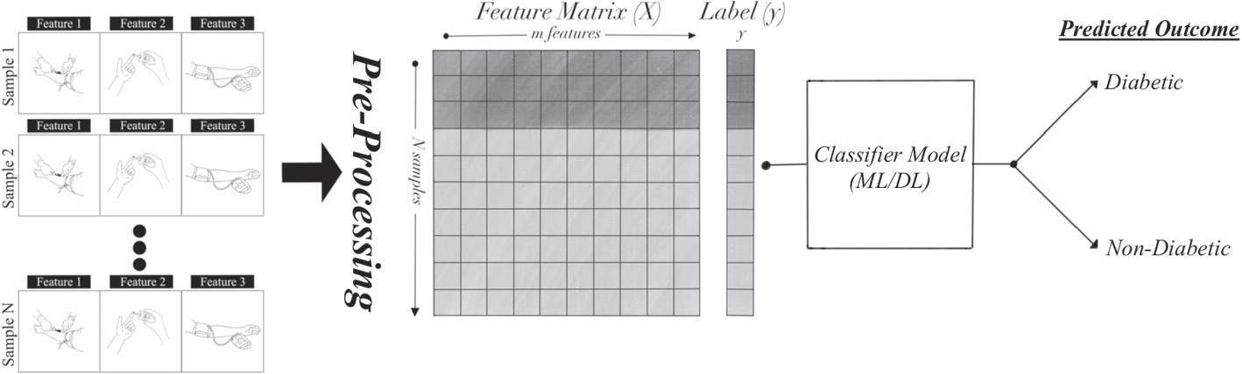

Figure 8 : Data Preprocessing

Chapter-2.1

INTRODUCTION TO DATASETS

Diabetes is still a major health problem worldwide and its prevalence is increasing in different populations. Early detection and appropriate treatment are important to prevent debilitating complications such as cardiovascular disease, kidney failure, and neuropathy. To address these issues, this project explores the application of machine learning algorithms to a variety of data to improve the prediction and diagnosis of diabetes. The project uses three
different datasets: the Pima Indian Population Dataset (PIDD), the National Health and Nutrition Examination Survey (NHANES), and the 130 US Diabetes Hospitals 1999-2008 dataset. Each dataset provides unique insights into factors associated with diabetes, from physical and social factors to clinical outcomes across multiple demographic groups.

Dataset-1: Pima Indians Diabetes Dataset (PIDD)

The PIDD dataset provides important information about diabetes among the Pima Indians, the population with the highest prevalence of the disease. This dataset includes factors such as glucose levels, insulin levels, BMI, and age, which are important in determining the onset and progression of diabetes in this population. This dataset comes from the National Institute of Diabetes and Digestive and Kidney Diseases. The purpose of the dataset is to accurately assess whether a patient has diabetes based on specific diagnostic criteria included in the dataset. Several restrictions were imposed on the selection of these samples from the large database. Specifically, all patients here were women of Pima heritage, at least 21 years of age.
Contents
Statistical analysis of multivariate clinical predictors and single-target variables, Results. Predictors included the number of pregnancies the patient had, body mass index, insulin levels, age, and more.

Dataset-2: National Health and Nutrition Examination Survey (NHANES)

The NHANES dataset provides detailed information on diabetes and related health conditions in the United States. It is ideal for investigating a broader epidemiological perspective on diabetes because it covers a wide range of factors, including demographics, dietary habits, physical activity levels, and clinical measurements.
The National Health and Nutrition Examination Survey (NHANES) is a research program designed to assess the health and nutrition of adults and children in the United States. The survey is unique because it combines questions with physical testing. NHANES is the flagship program of the National Center for Health Statistics (NCHS). The NCHS is part of the Centers for Disease Control and Prevention (CDC) and is responsible for providing health and wellness statistics for the country. The
NHANES program began in the early 1960s and was conducted as a series of studies focusing on different population groups or health issues. The study became an ongoing program in 1999 to focus on a variety of health and nutrition indicators to meet needs. The survey surveys a nationally representative sample of approximately 5,000 people per year. These people are located in 15 counties in the country, 15 of which are visited each year. The
NHANES survey includes demographic, socioeconomic, nutritional, and health questions. Components of the examination include medical, dental, and physiologic parameters, as well as laboratory tests performed by highly trained physicians. Almost, thousands of research findings have been published using the NHANES data.

Dataset-3: Diabetes 130-US Hospitals for Years 1999-2008
The Diabetes 130-US Hospitals dataset spans a decade and provides extensive hospital-based records related to diabetes care. It includes patient demographics, treatment regimens, and outcomes, offering insights into healthcare delivery and patient management strategies over time.

What examples do these figures show?
Sample data from patients hospitalized with a diagnosis of diabetes.
Is there any obligation to share information?
No request. A standard rail test unit can be used. You can use theway variance (i.e. training validation testing) when building a model.
Does the dataset contain any information that could be considered sensitive?
Yes. The dataset includes information on patient age, gender, and type.
Additional information
Dataset representing ten years (1999-2008) of care at 130 U.S. hospitals and affiliated networks. Includes more than 50 patient and hospital outcome reports. Information was extracted from the database that met the following criteria. (1) It is a medical appointment (hospitalization). (2) Encountering diabetes, that is, whenever diabetes is entered into the system as a diagnosis. (3) The duration of stay is at least 1 day and 14 days. (4) Laboratory tests were performed at the time of exposure. (5) Medications administered during the encounter. Data; number of patients, race, gender, age, method of admission, duration of hospital stay, doctor's specialty, number of laboratory tests performed, HbA1c test results, diagnosis, number of medications used, diabetes medications, outpatient, inpatient and emergency visits hospitalized in the previous year. number etc.
This project uses a structured approach that includes the use of data cleaning, exploratory data analysis, and machine learning. Statistics are performed before handling missing values, imputing factors, and verifying correlations between sources. Data analytics analyzes patterns and relationships needed to select features and validate the model.
Three key algorithms were implemented to predict and classify diabetes outcomes: Normal Forest, Support Vector Machine (SVM), and Logistic Regression. These algorithms were selected for their ability to solve complex data problems, categorize outcomes and accuracy, and provide insight into key decision-making factors.
This project aims to improve accuracy and efficiency in the diagnosis and prediction of diabetes by combining machine learning techniques with heterogeneous data. The findings contribute not only to the development of predictive health analytics, but also to the development of specific treatment strategies relevant to different patient populations.
Ultimately, this project strengthens the potential of data-driven approaches to address the diverse challenges of diabetes. By leveraging the power of machine learning algorithms and using a variety of metrics, it aims to provide healthcare providers with powerful tools for early intervention and improved patient outcomes.

Chapter – 3
Objectives
Goal – To explore different machine learning algorithms

1. Pima Indians Diabetes Database
- Predict Diabetes Onset: Develop models to predict diabetes based on physiological data.
- Identify Risk Factors: Determine key risk factors for diabetes in the Pima Indian population.
- Improve Diagnostic Criteria: Enhance early diagnosis criteria through data analysis.

2. NHANES 2013-2014
- Estimate Prevalence: Determine the prevalence of diabetes and prediabetes in the U.S.
- Analyze Nutrition and Lifestyle: Examine dietary and lifestyle factors influencing diabetes.
- Monitor Health Outcomes: Track complications and health outcomes related to diabetes.
- Inform Public Policy: Provide data to support public health policies and programs.

3. Diabetes 130-US Hospitals for Years 1999-2008
- Analyze Hospitalization Trends: Study trends in diabetes-related hospitalizations.
- Evaluate Treatment Efficacy: Assess the effectiveness of various diabetes treatments.
- Monitor Adverse Events: Identify and evaluate adverse events and complications in hospitalized diabetic patients.

Chapter-3.1

Objective-1

Data Preprocessing

The data entry phase is critical to any data analysis process. It involves cleaning and adjusting the database to ensure it is suitable for analysis. Statistical data is often inconsistent, including missing values, outliers, and inconsistencies that can distort analysis and predictive results. Processing transforms this underlying information into a clean, structured format, improving its quality and usability.
In this project, data processing was performed on files in the archive. The processed data is then saved in a clean format ready for analysis and display functions. This systematic step is important because it forms the basis for accurate and reliable data analysis useful for providing insights and making informed decisions.

Dataset-1: Pima Indians Diabetes Dataset (PIDD)
Steps Taken
- Loading the Data:
  - The R script began by loading the necessary libraries for data manipulation and cleaning. Libraries such as those for data manipulation and reading were used.
  - The raw data files from the archive were then loaded into R data frames using appropriate functions, depending on the file formats.
- Data Cleaning:
  - Handling Missing Values:
- Missing values are detected and resolved correctly. Techniques such as detrending values/intermediates or removing rows/columns with significant amounts of missing data were used.Outlier Detection and Treatment:
  - Outliers were identified using statistical methods and corrected or removed to avoid analysis of the results.Data Transformation:
    - Data was transformed to meet the requirements of the analysis. This included normalizing or standardizing numerical values, encoding categorical variables, and creating new derived variables if necessary.
  - Removing Duplicates:
  - Two documents were identified and removed to ensure uniqueness of the entered data.
- Data Integration:
  - If multiple files were involved, they were merged into a single data frame. This could involve joining datasets based on common keys or concatenating datasets with similar structures.
- Feature Selection:
  - Unnecessary columns that did not contribute to the analysis were removed to reduce dimensionality and improve computational efficiency.
- Key features are selected based on domain knowledge and previous analysis.
- Saving the Cleaned Data:
  - After thorough cleaning and transformation, the final dataset was saved in a cleaned format using appropriate functions. This file is now ready for further analysis and modelling.

Code: -

library(ggplot2)
library(dplyr)
library(readxl)
install.packages("tidyverse")
library(tidyverse)
install.packages("corrplot")
library(corrplot)
install.packages("leaflet")
library(leaflet)
install.packages("xlsx")
library(xlsx)
data1 <- pidd
columns_to_check <- c("Blood pressure", "Skin thickness", "Insulin","Body mass index")
df_clean <- data1[!apply(data1[columns_to_check], 1, function(row) any(row == 0)), ]
write.csv(df_clean,file="cleaned2.csv")

Dataset-2: National Health and Nutrition Examination Survey (NHANES)

Steps Taken:

1.Dataset Merging & Attribute selection
- Merge Datasets:
Datasets from the same cycle were merged using the unique participant identifier (SEQN). This integration included combining demographic, examination, laboratory, dietary, and questionnaire data into a single dataset. For analyses involving multiple cycles, datasets were harmonized by aligning variable names, formats, and coding schemes before merging.
- Attribute Selection:
Relevant variables were selected based on the research objectives. This step ensured that only necessary attributes were included for further analysis.
2. Handling Missing Values
- Missing valuewere addressed by removing the row containing the most missing data and imputing the missing value in numerical value using the median or mean and using the variance method.
3. Feature Selection:
- Variable Transformation:
New features were created from existing ones to enhance analysis. For example, BMI was calculated from height and weight, and age was categorized into groups (e.g., Child, Teen, Adult, Senior).
4.Dimensionality Reduction:
• Techniques such as Principal Component Analysis (PCA) or selection algorithms are used to reduce the number of variables while preserving important information.
5.Correlation Analysis:
Correlation analysis was performed to identify and remove highly correlated (redundant) variables.
6. Saving the Cleaned Data:
- After thorough cleaning and transformation, the final dataset was saved in a cleaned format using appropriate functions. This file is now ready for further analysis and modelling.

Code:-

import numpy as np
import pandas as pd
import pandas as pd
import seaborn as sns
import numpy as np
import matplotlib.pyplot as plt
import matplotlib as matplot
import re
import sklearn
import warnings
warnings.filterwarnings("ignore")
%matplotlib inline
df1 = pd.read_csv('labs.csv')
df2 = pd.read_csv('examination.csv')
df3 = pd.read_csv('demographic.csv')
df4 = pd.read_csv('diet.csv')
df5 = pd.read_csv('questionnaire.csv')
df2.drop(['SEQN'], axis = 1, inplace=True)
df3.drop(['SEQN'], axis = 1, inplace=True)
df4.drop(['SEQN'], axis = 1, inplace=True)
df5.drop(['SEQN'], axis = 1, inplace=True)
df = pd.concat([df1, df2], axis=1, join='inner')
df = pd.concat([df, df3], axis=1, join='inner')
df = pd.concat([df, df4], axis=1, join='inner')
df = pd.concat([df, df5], axis=1, join='inner')
df.describe()
df.to_csv('concatinated.csv', index=False)
from sklearn.feature_selection import VarianceThreshold
df.dropna(axis=1, how='all')
df.dropna(axis=0, how='all')
df = df.rename(columns = {'SEQN' : 'ID',
'RIAGENDR' : 'Gender', 'DMDYRSUS' : 'Years_in_US', # Nan -> american iguess
'INDFMPIR' : 'Family_income','LBXGH' : 'GlycoHemoglobin',
'BMXARMC' : 'ArmCircum','BMDAVSAD' : 'SaggitalAbdominal',
'MGDCGSZ' : 'GripStrength','DRABF' : 'Breast_fed'})
df = df.loc[:, ['ID', 'Gender', 'Years_in_US', 'Family_income','GlycoHemoglobin', 'ArmCircum',
'SaggitalAbdominal', 'GripStrength', 'Breast_fed']]
df.describe()
df.info()

Dataset-3: Diabetes 130-US Hospitals for Years 1999-2008

Steps Taken:
- Handling Missing Values
Missing values ​​were addressed by removing rows with significant amounts of missing data and imputing the missing value using the median or mean in numerical values ​​and by the variance and mode.
- Data Normalization
Normalization was applied to numerical features to standardize their scales. This process involved manipulating the data so that it fell within a certain range, usually between 0 and 1.
- Coding classes changed
Advertisements were converted to numerical values. Techniques such as one-hot encoding or label encoding were used to facilitate machine learning.
- Remote detection and removal
outliers were identified and removed using the Interquartile Range (IQR) method to avoid biased results. Observations that fell significantly outside the IQR were considered outliers.
Selection of functions
Unnecessary or redundant features were removed to improve model performance and reduce complexity. Correlation analysis and analysis of variance helped determine which factors should be removed.

5.The dataset is typically split between training and testing using an 80-20 ratio. This format allows for better evaluation and validation of the model.

Code: -

library(ggplot2)
library(dplyr)
library(readxl)
install.packages("tidyverse")
library(tidyverse)
install.packages("corrplot")
library(corrplot)
install.packages("leaflet")
library(leaflet)
data<- read.csv("C:/Users/Harshit/Documents/R files/diabetic_data.csv")
data1<- data %>%select(-encounter_id,-patient_nbr,-payer_code,-admission_type_id,-discharge_disposition_id,-admission_source_id) %>% filter(complete.cases(.))
mask <- apply(data1, 1, function(row) any(row == '?'))
data_ckeaned<- data1[!mask,]
Chapter-4
Algorithms

- Random Forest Algorithm

The Random Forest algorithm is a popular ensemble learning technique used for both classification and regression tasks. It operates by constructing a multitude of decision trees during training time and outputting the mode of the classes (classification) or mean prediction (regression) of the individual trees.
Here are the key concepts and steps involved in the Random Forest algorithm:

Figure 9 : Key concepts of Random Forest Algorithm

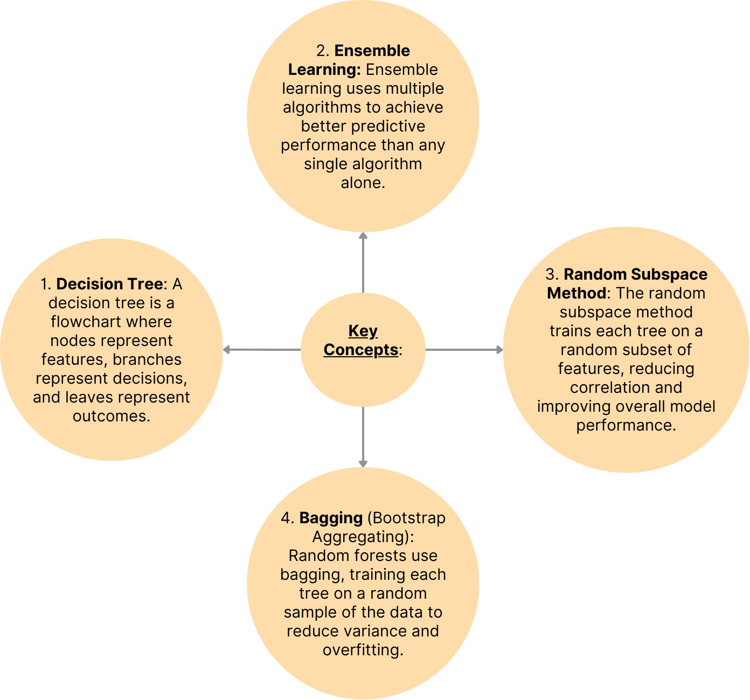

Advantages of Random Forest

- Robustness: It is less prone to overfitting compared to individual decision trees.
- Versatility: It can handle both classification and regression tasks.
- Feature Importance: It provides an estimate of feature importance, which can be useful for feature selection.
- Scalability: It can handle large datasets efficiently.

Disadvantages of Random Forest

- Complexity: It can be computationally intensive and require more memory.
- Interpretability: The results are less interpretable compared to a single decision tree, though some interpretability can be gained through feature importance scores.
- Slower Predictions: Predictions might be slower than some simpler models due to the ensemble of trees.

- SVM (Support Vector Machine) algorithm

SVM is a powerful supervised machine learning algorithm used for classification and regression tasks. It works by finding the optimal hyperplane that best separates data points belonging to different classes. Here’s an overview of the SVM algorithm:

Advantages of SVM

- Effective in High-Dimensional Spaces: SVM performs well even when the number of dimensions is greater than the number of samples.
- Memory Efficient: It uses a subset of training points (support vectors) in the decision function, making it memory efficient.
- Versatile: SVM can be used for both classification and regression tasks, and with appropriate kernel functions, it can handle complex decision boundaries.
- Regularization: SVM has a regularization parameter (C) that helps prevent overfitting by balancing between maximizing the margin and minimizing classification error.

Figure 10 : Key concepts of SVM algorithm

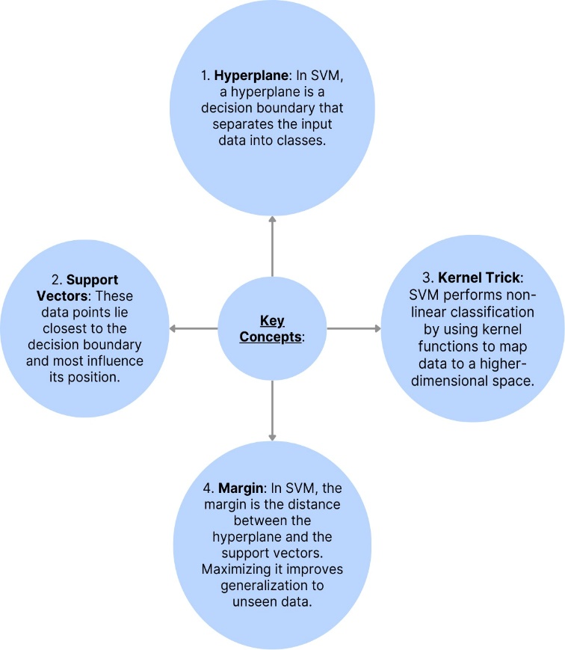

Disadvantages of SVM

- Computationally Expensive: Training time can be high for large datasets.
- Choice of Kernel: The performance of SVM depends heavily on the choice of kernel. Selecting the right kernel and tuning its parameters can be challenging.
- Difficulty in Interpretation: Unlike decision trees or linear regression, SVM models are not easily interpretable.

Logistic Regression Algorithm

Logistic regression is a widely used statistical method for binary classification tasks. It predicts the probability of occurrence of an event by fitting data to a logistic function. Here are the key concepts and characteristics of logistic regression:

Figure 11 : Key concepts of logistic regression algorithm

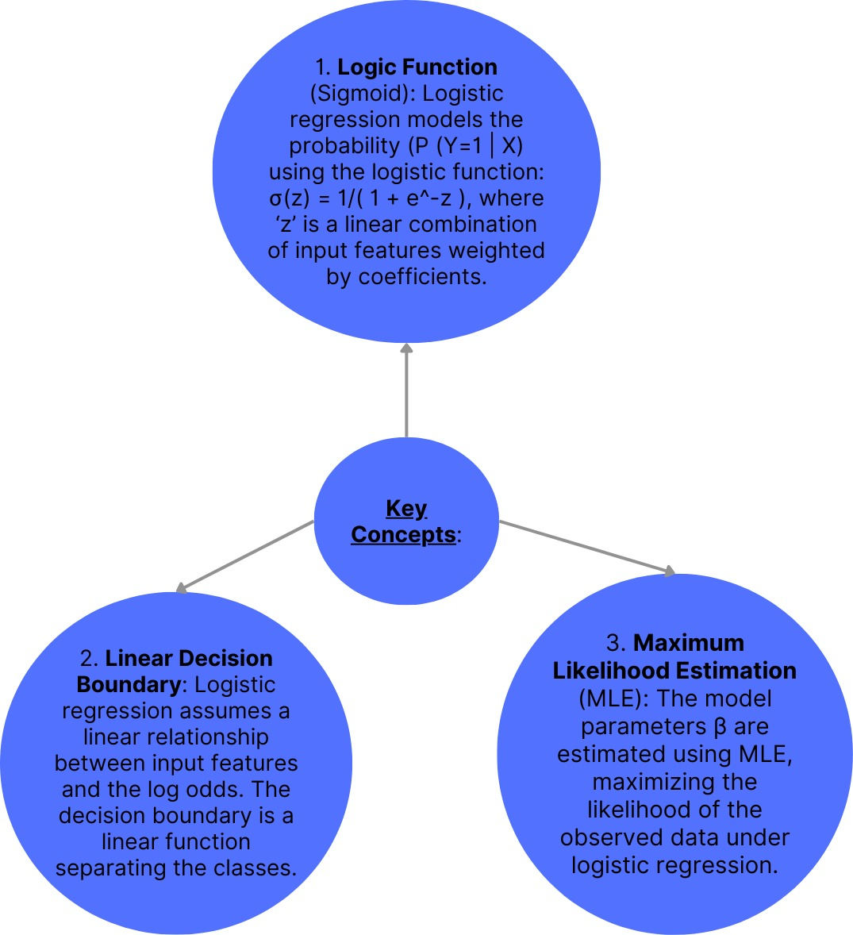

Advantages of Logistic Regression

- Interpretability: Logistic regression provides straightforward interpretation of coefficients. Each coefficient represents the change in log-odds of the outcome associated with a one-unit change in the predictor, holding other predictors constant.

- Efficiency: It is computationally efficient and can be trained quickly, even with large datasets.
- Probabilistic Predictions: Outputs probabilities that a given observation belongs to a particular class, enabling flexible thresholding for decision-making.
- Feature Importance: Although not as direct as in tree-based models, feature importance can be inferred from the magnitude and sign of coefficients.

Disadvantages of Logistic Regression

- Linear Assumption: Logistic regression assumes a linear relationship between the features and the log-odds of the outcome, which may not hold true for complex, non-linear relationships in the data.
- Limited Expressiveness: It may not capture complex interactions between features without feature engineering or transformation.
- Binary Classification Limitation: Primarily designed for binary classification tasks and may not perform well for multi-class problems without extensions like multinomial logistic regression.

Chapter-4.1
Objective-2
Performance and Classification

Random Forest Algorithm on Dataset-1: Pima Indians Diabetes Dataset (PIDD)
Code: -
import pandas as pd
from sklearn.model_selection import train_test_split
from sklearn.ensemble import RandomForestClassifier
from sklearn.metrics import classification_report, accuracy_score
# Load the dataset
df = pd.read_csv('cleaned2.csv')
# Drop the unnamed column
df = df.drop(columns=['Unnamed: 0'])
# Define features (X) and target (y)
X = df.drop(columns=['Outcome'])
y = df['Outcome']
# Split the data into training and testing sets
X_train, X_test, y_train, y_test = train_test_split(X, y, test_size=0.2, random_state=42)
# Create a Random Forest Classifier
rf = RandomForestClassifier(n_estimators=100, random_state=42)
# Train the classifier
rf.fit(X_train, y_train)
# Make predictions
y_pred = rf.predict(X_test)
# Evaluate the model
accuracy = accuracy_score(y_test, y_pred)
report = classification_report(y_test, y_pred)
# Print the results
print(f'Accuracy: {accuracy:.2f}')
print('Classification Report:')
print(report)

Output: -
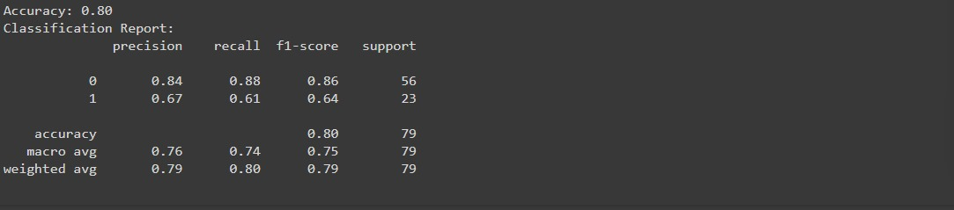
Random Forest Algorithm Dataset-2: National Health and Nutrition Examination Survey (NHANES)

Code:
import pandas as pd
from sklearn.model_selection import train_test_split
from sklearn.ensemble import RandomForestClassifier
from sklearn.metrics import accuracy_score, precision_score, recall_score, f1_score, confusion_matrix, classification_report
# Load the dataset
file_path = '/content/random.csv'
df = pd.read_csv(file_path)
# Impute all numerical columns with mean
for col in df.select_dtypes(include=['float64', 'int64']).columns:
df[col].fillna(df[col].mean(), inplace=True)
# Encode categorical variables (if any)
# Assuming 'Gender' is categorical
df['Gender'] = df['Gender'].astype('category').cat.codes
# Convert 'Breast_fed' to categorical if it is not already
df['GlycoHemoglobin'] = df['GlycoHemoglobin'].astype('int')
# Ensure there are no missing values left
assert df.isnull().sum().sum() == 0, "There are still missing values in the dataset"
# Split the data into features and target
# Assuming 'Breast_fed' is the target variable
X = df.drop(columns=['GlycoHemoglobin'])
y = df['GlycoHemoglobin']
# Check unique values in the target to ensure it's categorical
print(y.unique())
# Split the dataset into training and testing sets
X_train, X_test, y_train, y_test = train_test_split(X, y, test_size=0.2, random_state=42)
# Train the Random Forest model
model = RandomForestClassifier(n_estimators=100, random_state=42)
model.fit(X_train, y_train)
# Make predictions on the test set
y_pred = model.predict(X_test)
# Evaluate the model
accuracy = accuracy_score(y_test, y_pred)
precision = precision_score(y_test, y_pred, average='macro')
recall = recall_score(y_test, y_pred, average='macro')
f1 = f1_score(y_test, y_pred, average='macro')
conf_matrix = confusion_matrix(y_test, y_pred)
class_report = classification_report(y_test, y_pred)
# Print the evaluation metrics
print("Accuracy:", accuracy)
print("Precision:", precision)
print("Recall:", recall)
print("F1 Score:", f1)
print("\nConfusion Matrix:\n", conf_matrix)
print("\nClassification Report:\n", class_report)

Output:

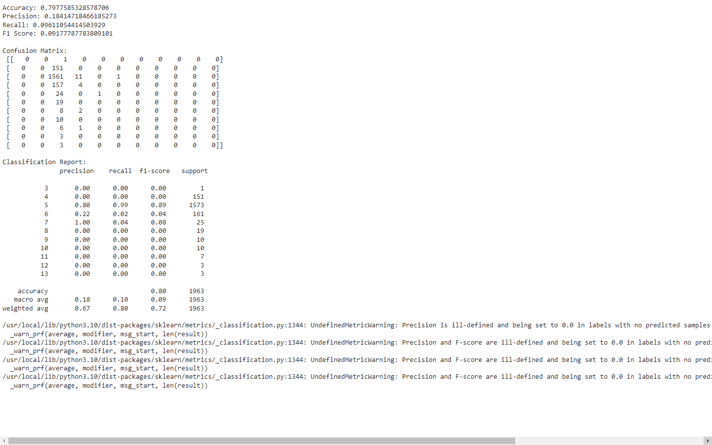

Random Forest Algorithm Dataset-3: Diabetes 130-US Hospitals for Years 1999-2008
Code: -
# Step 1: Import necessary libraries
import pandas as pd
from sklearn.model_selection import train_test_split
from sklearn.ensemble import RandomForestClassifier
from sklearn.metrics import accuracy_score, classification_report
from sklearn.impute import SimpleImputer
# Step 2: Load your dataset
df = pd.read_csv('cleaned1.csv')
# Print column names to verify
print("Column names in the dataset before get_dummies:")
print(df.columns)

# Step 3: Preprocess your data
# Convert categorical features to numerical using get_dummies
df = pd.get_dummies(df)
# Print column names again after get_dummies
print("Column names in the dataset after get_dummies:")
print(df.columns)
# Combine 'readmitted' columns into a single binary column
df['readmitted'] = df[['readmitted_<30', 'readmitted_>30']].max(axis=1)
# Drop the original 'readmitted' columns
df.drop(columns=['readmitted_<30', 'readmitted_>30', 'readmitted_NO'], inplace=True)
# Step 4: Separate features and target variable
X = df.drop(columns='readmitted')
y = df['readmitted']
# Fill missing values with mean
imputer = SimpleImputer(strategy='mean')
X = imputer.fit_transform(X)
# Step 5: Split the dataset into training and testing sets
X_train, X_test, y_train, y_test = train_test_split(X, y, test_size=0.2, random_state=42)
# Step 6: Train the Random Forest model
rf = RandomForestClassifier(n_estimators=100, random_state=42)
rf.fit(X_train, y_train)
# Step 7: Make predictions and evaluate the model
y_pred = rf.predict(X_test)
accuracy = accuracy_score(y_test, y_pred)
report = classification_report(y_test, y_pred)
print(f"Accuracy: {accuracy}")
print("Classification Report:")
print(report)
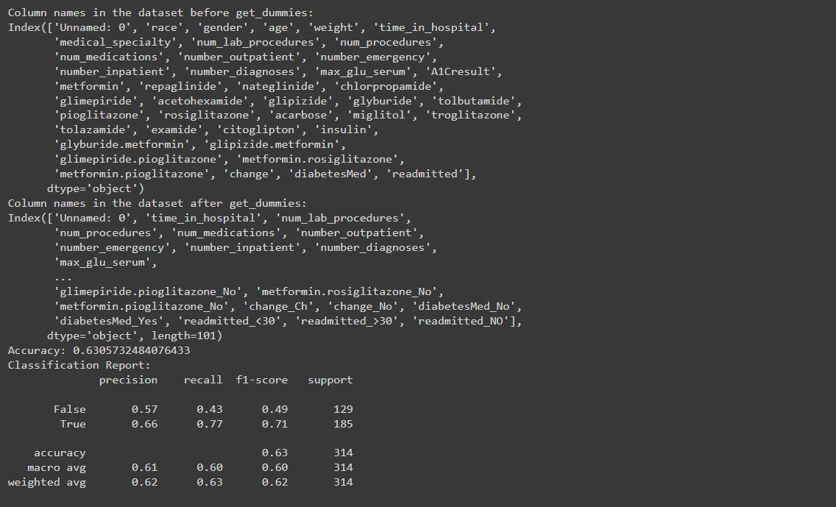
Output: -

SVM (Support Vector Machine) Algorithm
Dataset-1: Pima Indians Diabetes Dataset (PIDD)

Code: -

import pandas as pd
from sklearn.model_selection import train_test_split
from sklearn.svm import SVC
from sklearn.metrics import classification_report, accuracy_score
from sklearn.preprocessing import StandardScaler
# Load the dataset
df = pd.read_csv('cleaned2.csv')
# Drop the unnamed column
df = df.drop(columns=['Unnamed: 0'])
# Define features (X) and target (y)
X = df.drop(columns=['Outcome'])
y = df['Outcome']
# Split the data into training and testing sets
X_train, X_test, y_train, y_test = train_test_split(X, y, test_size=0.2, random_state=42)
# Feature scaling
scaler = StandardScaler()
X_train = scaler.fit_transform(X_train)
X_test = scaler.transform(X_test)
# Create an SVM classifier
svm = SVC(kernel='linear', random_state=42)
# Train the classifier
svm.fit(X_train, y_train)
# Make predictions
y_pred = svm.predict(X_test)
# Evaluate the model
accuracy = accuracy_score(y_test, y_pred)
report = classification_report(y_test, y_pred)
# Print the results
print(f'Accuracy: {accuracy:.2f}')
print('Classification Report:')
print(report)

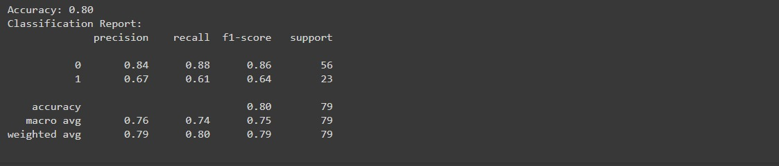
Output: -

SVM (Support Vector Machine) Algorithm Dataset -2: National Health and Nutrition Examination Survey (NHANES)

Code:-

import pandas as pd
from sklearn.model_selection import train_test_split
from sklearn.svm import SVC
from sklearn.metrics import accuracy_score, precision_score, recall_score, f1_score, confusion_matrix, classification_report
# Load your data
data = pd.read_csv("/content/random.csv")
# Define features (independent variables) and target variable
features = data.drop("GlycoHemoglobin", axis=1) # Replace "GlycoHemoglobin" with your actual target column name
target = data["GlycoHemoglobin"]
# Split data into training and testing sets
X_train, X_test, y_train, y_test = train_test_split(X, y, test_size=0.2, random_state=42)
# Create and train the logistic regression model
model = SVC(random_state=42)
model.fit(X_train, y_train)
# Make predictions on the testing set
y_pred = model.predict(X_test)
# Evaluate model performance (e.g., accuracy score)
#from sklearn.metrics import accuracy_score
accuracy = accuracy_score(y_test, y_pred)
precision = precision_score(y_test, y_pred, average='macro')
recall = recall_score(y_test, y_pred, average='macro')
f1 = f1_score(y_test, y_pred, average='macro')
conf_matrix = confusion_matrix(y_test, y_pred)
class_report = classification_report(y_test, y_pred)
# Print the classification report
print("Accuracy:", accuracy)
print("Precision:", precision)
print("Recall:", recall)
print("F1 Score:", f1)
print("\nConfusion Matrix:\n", conf_matrix)
print("\nClassification Report:\n", class_report)

Output:-
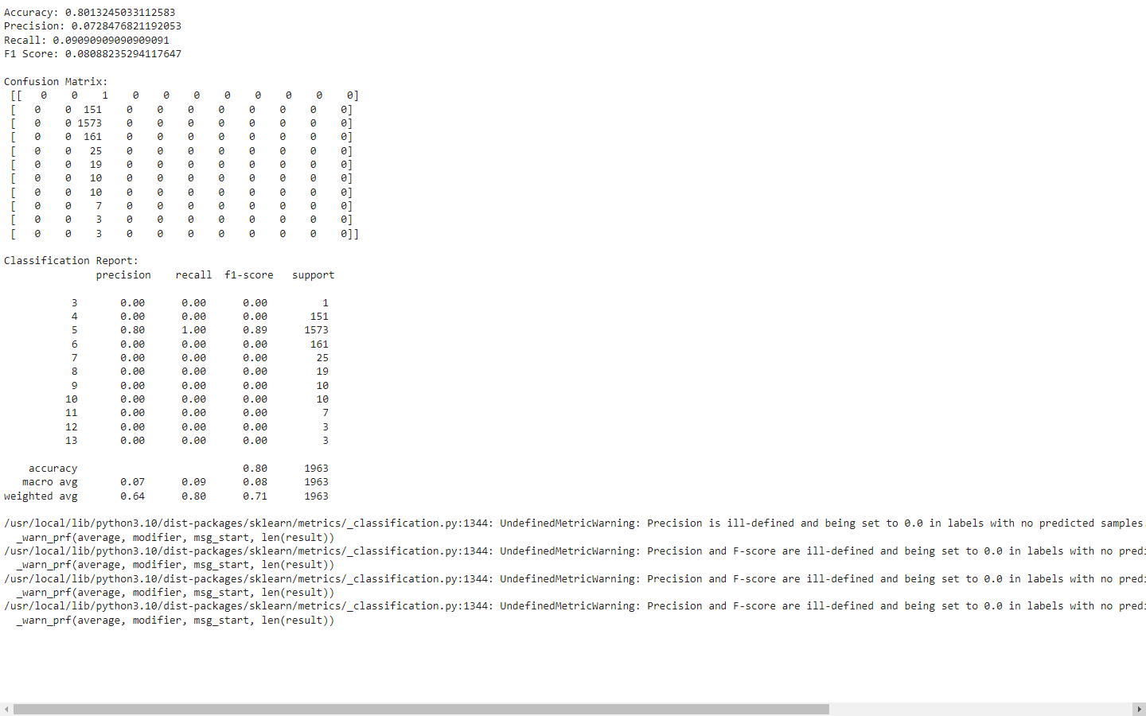

SVM (Support Vector Machine) Algorithm
Dataset-3: Diabetes 130-US Hospitals for Years 1999-2008

Code: -

# Step 1: Import necessary libraries
import pandas as pd
from sklearn.model_selection import train_test_split
from sklearn.impute import SimpleImputer
from sklearn.preprocessing import StandardScaler
from sklearn.svm import SVC
from sklearn.metrics import accuracy_score, classification_report
# Step 2: Load your dataset
df = pd.read_csv('cleaned1.csv')
# Print column names to verify
print("Column names in the dataset before get_dummies:")
print(df.columns)
# Step 3: Preprocess your data
# Convert categorical features to numerical using get_dummies
df = pd.get_dummies(df)
# Print column names again after get_dummies
print("Column names in the dataset after get_dummies:")
print(df.columns)
# Combine 'readmitted' columns into a single binary column
df['readmitted'] = df[['readmitted_<30', 'readmitted_>30']].max(axis=1)
# Drop the original 'readmitted' columns
df.drop(columns=['readmitted_<30', 'readmitted_>30', 'readmitted_NO'], inplace=True)

# Step 4: Separate features and target variable
X = df.drop(columns='readmitted')
y = df['readmitted']
# Fill missing values with mean
imputer = SimpleImputer(strategy='mean')
X = imputer.fit_transform(X)
# Standardize the features
scaler = StandardScaler()
X = scaler.fit_transform(X)
# Step 5: Split the dataset into training and testing sets
X_train, X_test, y_train, y_test = train_test_split(X, y, test_size=0.2, random_state=42)
# Step 6: Train the SVM model
svm = SVC(kernel='linear', random_state=42)
svm.fit(X_train, y_train)
# Step 7: Make predictions and evaluate the model
y_pred = svm.predict(X_test)
accuracy = accuracy_score(y_test, y_pred)
report = classification_report(y_test, y_pred)
print(f"Accuracy: {accuracy}")
print("Classification Report:")
print(report)
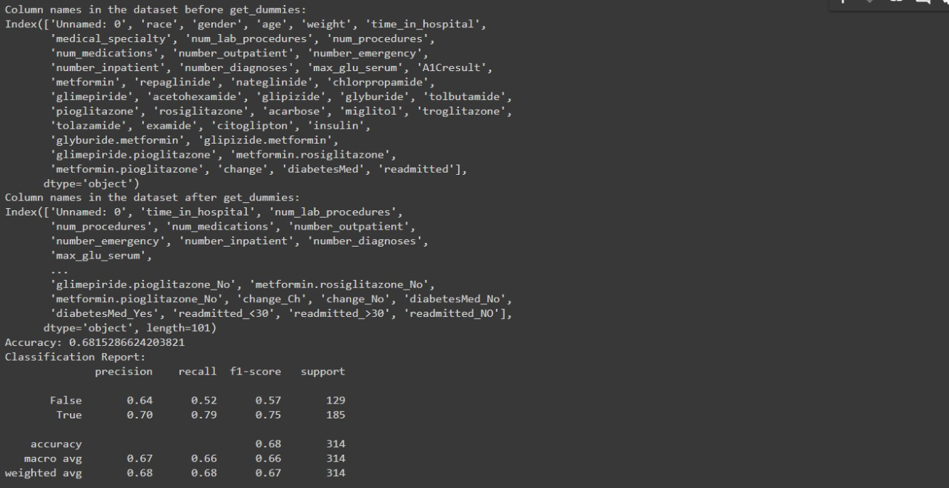
Output: -

Logistic Regression Algorithm Dataset-1: Pima Indians Diabetes Dataset (PIDD)

Code: -
import pandas as pd
from sklearn.model_selection import train_test_split
from sklearn.linear_model import LogisticRegression
from sklearn.metrics import classification_report, accuracy_score
from sklearn.preprocessing import StandardScaler

# Load the dataset
df = pd.read_csv('cleaned2.csv')
# Drop the unnamed column
df = df.drop(columns=['Unnamed: 0'])
# Define features (X) and target (y)
X = df.drop(columns=['Outcome'])
y = df['Outcome']
# Split the data into training and testing sets
X_train, X_test, y_train, y_test = train_test_split(X, y, test_size=0.2, random_state=42)
# Feature scaling
scaler = StandardScaler()
X_train = scaler.fit_transform(X_train)
X_test = scaler.transform(X_test)
# Create a Logistic Regression model
lr = LogisticRegression(random_state=42)
# Train the model
lr.fit(X_train, y_train)
# Make predictions
y_pred = lr.predict(X_test)
# Evaluate the model
accuracy = accuracy_score(y_test, y_pred)
report = classification_report(y_test, y_pred)
# Print the results
print(f'Accuracy: {accuracy:.2f}')
print('Classification Report:')
print(report)
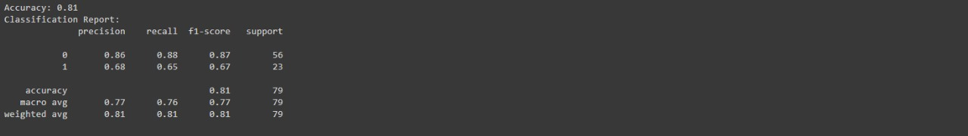
Output: -

Logistic Regression Algorithm Dataset-2: National Health and Nutrition Examination Survey (NHANES)
Code:
import pandas as pd
from sklearn.model_selection import train_test_split
from sklearn.linear_model import LogisticRegression
from sklearn.metrics import accuracy_score, precision_score, recall_score, f1_score, confusion_matrix, classification_report
# Load your data
data = pd.read_csv("/content/random.csv")
# Define features (independent variables) and target variable
features = data.drop("GlycoHemoglobin", axis=1) # Replace "GlycoHemoglobin" with your actual target column name
target = data["GlycoHemoglobin"]
# Split data into training and testing sets
X_train, X_test, y_train, y_test = train_test_split(X, y, test_size=0.2, random_state=42)
# Create and train the logistic regression model
model = LogisticRegression(random_state=42)
model.fit(X_train, y_train)
# Make predictions on the testing set
y_pred = model.predict(X_test)
# Evaluate model performance (e.g., accuracy score)
#from sklearn.metrics import accuracy_score
accuracy = accuracy_score(y_test, y_pred)
precision = precision_score(y_test, y_pred, average='macro')
recall = recall_score(y_test, y_pred, average='macro')
f1 = f1_score(y_test, y_pred, average='macro')
conf_matrix = confusion_matrix(y_test, y_pred)
class_report = classification_report(y_test, y_pred)
# Print the classification report
print("Accuracy:", accuracy)
print("Precision:", precision)
print("Recall:", recall)
print("F1 Score:", f1)
print("\nConfusion Matrix:\n", conf_matrix)
print("\nClassification Report:\n", class_report)

Output:-
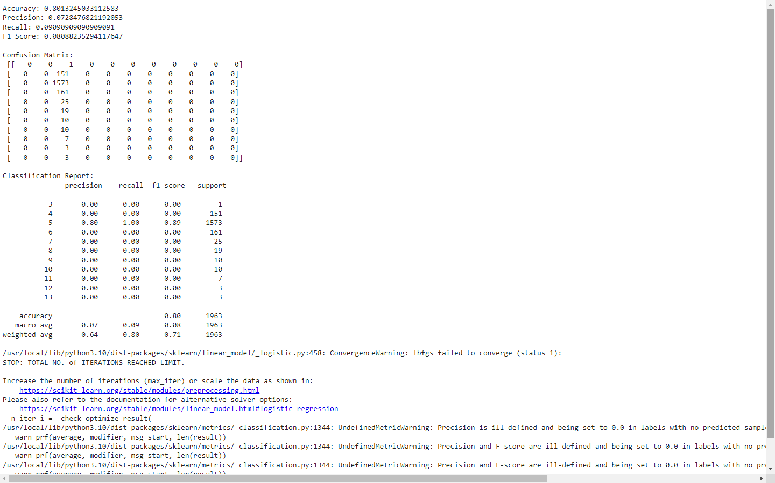

Logistic Regression Algorithm
Dataset-3: Diabetes 130-US Hospitals for Years 1999-2008

Code:-
# Step 1: Import necessary libraries
import pandas as pd
from sklearn.model_selection import train_test_split
from sklearn.impute import SimpleImputer
from sklearn.preprocessing import StandardScaler
from sklearn.linear_model import LogisticRegression
from sklearn.metrics import accuracy_score, classification_report
# Step 2: Load your dataset
df = pd.read_csv('cleaned1.csv')
# Print column names to verify
print("Column names in the dataset before get_dummies:")
print(df.columns)
# Step 3: Preprocess your data
# Convert categorical features to numerical using get_dummies
df = pd.get_dummies(df)
# Print column names again after get_dummies
print("Column names in the dataset after get_dummies:")
print(df.columns)
# Combine 'readmitted' columns into a single binary column
df['readmitted'] = df[['readmitted_<30', 'readmitted_>30']].max(axis=1)
# Drop the original 'readmitted' columns
df.drop(columns=['readmitted_<30', 'readmitted_>30', 'readmitted_NO'], inplace=True)
# Step 4: Separate features and target variable
X = df.drop(columns='readmitted')
y = df['readmitted']
# Fill missing values with mean
imputer = SimpleImputer(strategy='mean')
X = imputer.fit_transform(X)
# Standardize the features
scaler = StandardScaler()
X = scaler.fit_transform(X)
# Step 5: Split the dataset into training and testing sets
X_train, X_test, y_train, y_test = train_test_split(X, y, test_size=0.2, random_state=42)
# Step 6: Train the Logistic Regression model
lr = LogisticRegression(random_state=42, max_iter=1000)
lr.fit(X_train, y_train)
# Step 7: Make predictions and evaluate the model
y_pred = lr.predict(X_test)
accuracy = accuracy_score(y_test, y_pred)
report = classification_report(y_test, y_pred)
print(f"Accuracy: {accuracy}")
print("Classification Report:")
print(report)

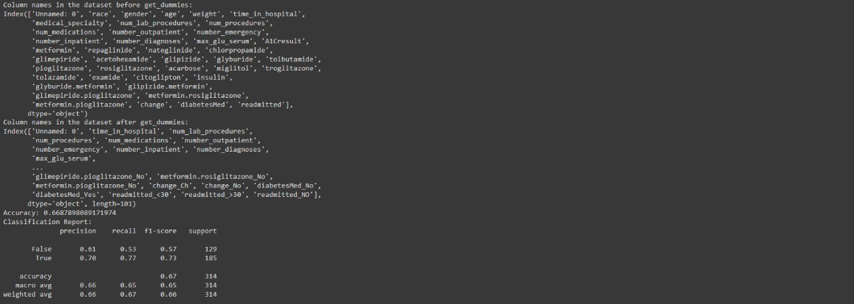
Output: -

S.No | Random Forest Algorithm  Accuracy | SVM (Support Vector Machine) Algorithm Accuracy | Logistic Regression Algorithm Accuracy
Dataset-1: Pima Indians Diabetes Dataset (PIDD) | 80% | 80% | 81%
Dataset-2: National Health and Nutrition Examination Survey (NHANES) | 79% | 80% | 80%
Dataset-3: Diabetes 130-US Hospitals for Years 1999-2008 | 63% | 68% | 66%

Figure 12 : Table for accuracy Values of Different Datasets

Chapter-5

CONCLUSION

Each model demonstrated strengths and weaknesses based on the specific characteristics of the datasets. The Logistic Regression Algorithm showed the highest accuracy with the Pima Indians Diabetes Dataset, indicating its suitability for smaller, more defined datasets. Random Forest, despite its lower accuracy on the Diabetes 130-US Hospitals for Years 1999-2008 dataset, offered valuable insights into high-dimensional health data. Linear Regression was effective in predicting outcomes in the Pima Indians Diabetes Dataset (PIDD), though its performance relies on linear assumptions.

Future Work

Future work will focus on optimizing these models, particularly addressing the limitations observed with Random Forest, to improve overall performance and provide deeper insights into diabetes management. Exploring other algorithms and applying them on datasets .Exploring the future technology trends in Healthcare field for prediction of Diabetics and other Diseases.

References & Links

Dataset-

https://archive.ics.uci.edu/dataset/296/diabetes+130-us+hospitals+for+years+1999-2008
https://www.kaggle.com/datasets/jimschacko/10-years-diabetes-dataset/data

https://www.kaggle.com/datasets/uciml/pima-indians-diabetes-database/data

https://www.kaggle.com/datasets/cdc/national-health-and-nutrition-examination-survey

Papers-

https://www.sciencedirect.com/science/article/pii/S1877050920308024#cebibsec1

https://link.springer.com/article/10.1007/s11042-023-16407-5#article-info

Images –

https://link.springer.com/article/10.1007/s11042-023-16407-5/figures/6

